KHUSHI SHARMA

CLASS: CSME A

ROLL NO: 2000321530064

________________________PRACTICAL-1________________________

1. **STATEMENT OF PRACTICAL:** Multiplication of 2 given matrix.
2. **OBJECTIVE OF PRACTICAL:**

Write a program in c to enter 2 matrix and perform multiplication operation on them.

**3. ALGORITHM:**

1)Enter the first matrix 2)Enter the second matrix

3)Check whether no.of column of matrix 1= no. of rows of matrix 2

4)Multiply the matrix and store output in empty matrix C

5)Print Multiplied matrix C

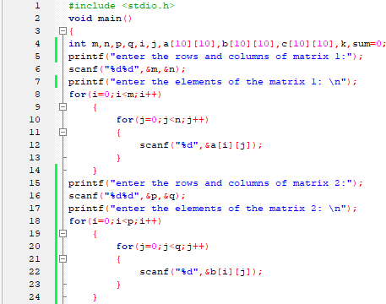 **4:IMPLEMENTATION:**

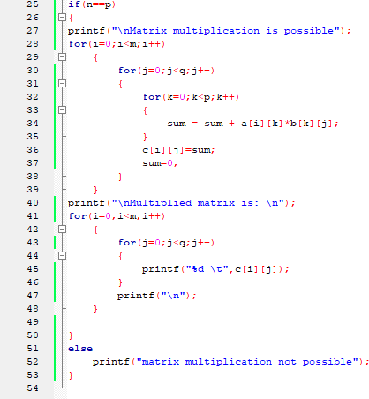

**5:OUTPUT:**

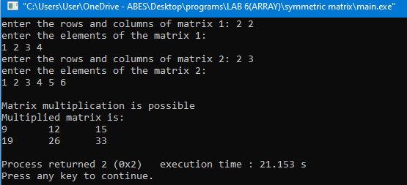

___________________________PRACTICAL-2___________________________

1. **STATEMENT OF PRACTICAL:** Union of 2 sets.
2. **OBJECTIVE OF PRACTICAL:**

Write a program in c to create 2 sets and perform union operation on sets.

**3.ALGORITHM:**

1)Initialize union set C[][] as empty

2)Copy all elements of first array to C

3)If x is not present in First array then copy x to C 4)Return C

**4.IMPLEMENTATION:**

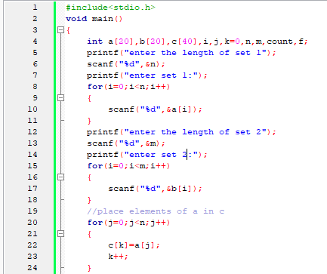

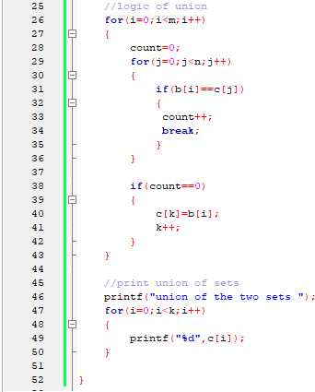

**5:OUTPUT:**

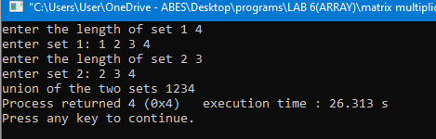

_________________________PRACTICAL-3_____________________________

1. **STATEMENT OF PRACTICAL:** Intersection of 2 given sets.
2. **OBJECTIVE OF PRACTICAL:**

Write a program in c to create 2 sets and perform intersection operation on sets. 3. **ALGORITHM:**

1. Initialize intersection set C[][] as empty
2. Do following for every element x of first array a.if x is present in 2nd array, then copy x to C
3. Return C **4.IMPLEMENTATION**

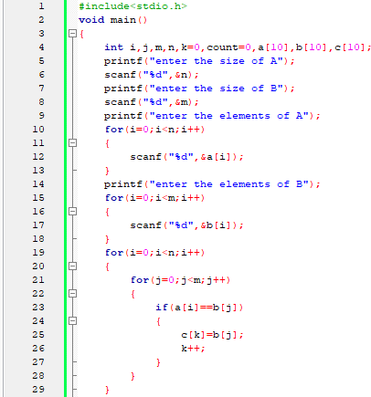

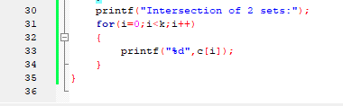

**5:OUTPUT:**

